Police Warriors who attained martyrdom during COVID 19 Pandemic( First Phase)
S.No | Name & Rank | PID. No | Unit | D.O.D | Photograph
1 | SI Amar Singh | EXJ-845442 | Security Jammu | 29.09.2020 | 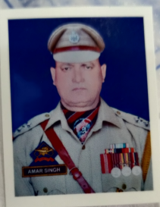
2 | ASI Hafizllah Najar | EXK-891853 | Security Kashmir | 06.07.2020 | 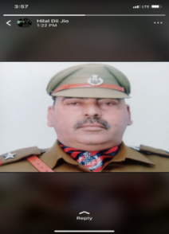
3 | ASI Mohd.Yameen | EXK-872852 | CID CIK Kmr | 12.07.2020 | 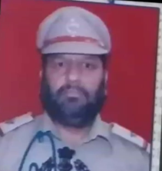
4 | ASI Ashok Kumar | ARP-835902 | IR 18TH BN | 24.07.2020 | 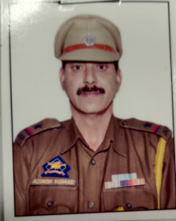
5 | ASI Ab.Majid | EXK-872501 | Distt.KUPWARA | 26.07.2020 | 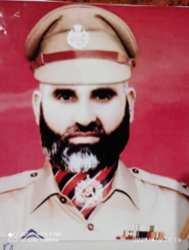
6 | ASI Mohd.Hussain | EXK-891762 | PD Awantipora | 31.07.2020 | 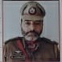
7 | ASI Mohd.Ramzan | EXK-873228 | PD Awantipora | 07.08.2020 | 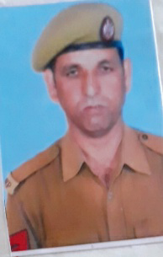
8 | HC Mushtaq Ahmed | EXJ-955490 | Distt. Jammu | 13.08.2020 | 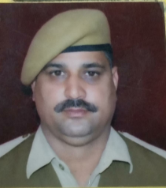
9 | HC Rajinder Singh | EXJ-956377 | Traffic City Jammu | 14.08.2020 | 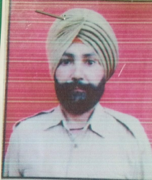
10 | HC Vir Vikram | ARP-925823 | IR 22nd BN | 27.11.2020 | 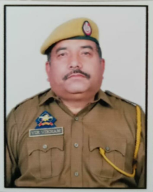
11 | HC Gh.Mohmmad Mir | EXE-915633 | SDRF Kashmir | 20.09.2020 | 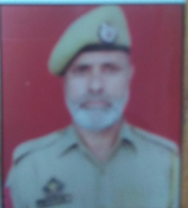
12 | SgCt.Ab Rashid Wani | EXK-982820 | Police Hospital  Srinagar | 16.09.2020
13 | W/Ct Jabina Bank | ARP-095914 | IR 4TH BN. | 04.09.2020 | 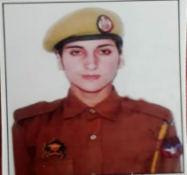
14 | Ct Gh Hussain | EXJ-116330 | Distt.Doda | 14.09.2020 | 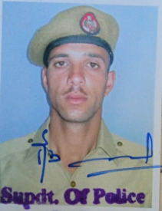
15 | Foll.Mohinder Singh | ARP- 876170 | IR 11th Bn | 02.08.2020 | 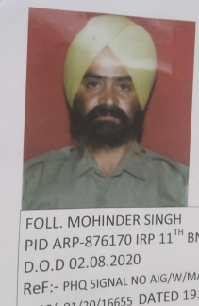

Police Warriors who attained martyrdom during COVID 19 Pandemic(Second Phase)
S.No |  | Name of deceased | PID No. |  |  | Unit | Rank | D.O.D | Photograph
1 |  | Ravinder Singh | EXK 951922 |  |  | Distt.Srinagar | HC | 05-05-2021 | 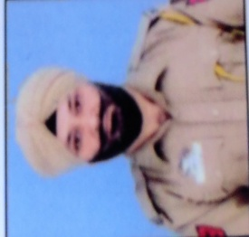
2 |  | Parshotam Lal | PRO 936110 |  |  | PHQ J&K | DDP | 07-05-2021 | 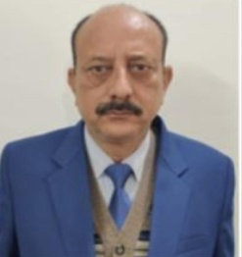
3 |  | Ashwani Kumar | EXJ 891612 |  |  | Distt.Jammu | ASI | 08-05-2021 | 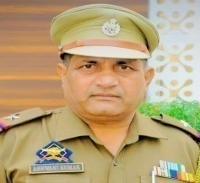
4 |  | Hafiz-ul-Rehman | ARP 825908 |  |  | IRP 2nd Bn | ASI | 20-05-2021 | 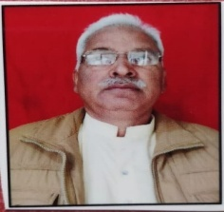
5 |  | Noor Mohammad | ARP 842320 |  |  | JKAP 5th BN | HC | 06-05-2021 | 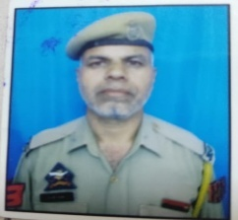
6 |  | Nirmal Subh | EXJ 055619 |  |  | Distt.Jammu | Foll. | 09-06-2021 | 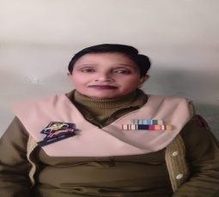
7 |  | Raj Singh | ARP 993450 |  |  | IRP 20th BN | Sgct. | 13-06-2021 | 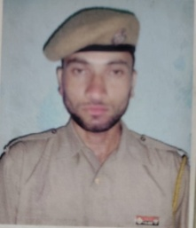
8 |  | Ghulam Nabi Giri | EXJ 815525 |  |  | CID CIJ | SI | 16-07-2021 | 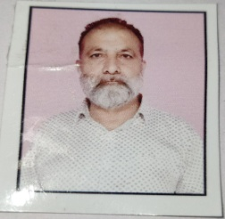
Police Warriors( SPOs) who attained martyrdom during COVID 19 Pandemic( Second Phase)
1 | Mahmooda Akhter D/o Mohammad Ramzan Sofi R/o Marhama Bijbehar,Anantnag |  |  | 11-05-21 |  | Distt.Anantnag |  | SPO | 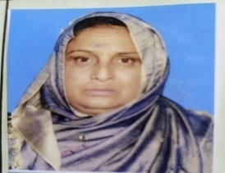
2 | Deepak Raj S/O Tarseem Lar R/o Rajbagh Tehsil Marheen |  |  | 14-05-21 |  | Distt.Kathua |  | SPO | 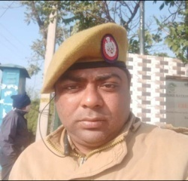
3 | Surinnder Singh S/o Atama Singh R/o Qila Darhal Rajouri |  |  | 14-06-21 |  | Distt.Rajoouri |  | SPO | 